Community Report for Hospers, IA

Jamie Pohlen

HSC-315 Introduction to Public Health

University of South Dakota

Angela Landeen

February 15th, 2021

**Community Profile**

Located in Northwestern Iowa, Hospers is a small yet prosperous and thriving community. Old highway 60 runs through the western part of the town, which is barely traveled, just by the in-town commuters. The new state highway 60 bypass, which was upgraded in 2004 is located on the outskirts of the eastern side of town. This new highway gets lots of out of state travelers, which providers business to the community. According to the City of Hospers, “Hospers is a small town with big ideas” (City of Hospers, 2013).

The first occupant of Hospers, Iowa was Henry Hospers. Henry Hospers settled in the town between 1869-1872. According to The University of Iowa Libraries (2009) Henry was an Iowa banker, a developer, and a reserved schoolteacher. After he settled, he ended up getting many Dutch and German settlers to relocate to the Sioux county area. The settlers wanted to move to the Northwest corner of Iowa to farm the rich and plentiful land. This town has a rich history before settlers even moved to it, it was originally a depot stop for the St. Paul and Sioux City railroad and was called the North Orange, which was renamed to Hospers in 1895 to honor Henry (The University of Iowa Libraries, 2009).

**Demographic Makeup/Population Density**

The following data is reported from the World Population Review (2021), the data that is shown estimates the population of Hospers, which is approximately 686 as of 2020 according to the latest US census. Which has decreased slightly over the past couple of years. The city of Hospers has a population density of 1,363 people per square mile. According to the World Population Review (2021), they reported that there are more whites than any other races with whites taking up 98.48% of the community’s population. The male to female sex ratio of Hospers, Iowa is pretty much even with 49% females and 51% males. The median age of this community is 36 years, which shows that the community will potentially grow with the younger families potentially coming in. There are approximately 601 adults with 149 of them being seniors.

**Income and Education**

According to the World Population Review (2021) they report the average household income in Hospers is $74,884 with a poverty rate of 2.28%. The educational levels vary from 9th grade to bachelor’s degree with the highest getting some sort of college education. The amount of people that have a high school diploma is around 32%, and a bachelor’s degree being around 16% (World Population Review, 2021).

**Employment Opportunities in Hospers**

The top employment in this community includes Den Hartog, Fred’s, Premium Iowa Pork, private businesses like the café, salons, and construction companies. 68.5% of the people in Hospers are employed with an unemployment rate 1.9% with the most popular age of employment being between 35-44 (World Population Review, 2021).

**Healthcare Accessibility**

Hospers is fortunate to have access to a medical clinic and a Sanford Health Dialysis Center. The clinic has three primary physicians, which specializes in family medicine. The clinic in Hospers is based out of the Orange City Health Care System which is approximately 8 miles south of Hospers. Both of these facilities provide routine medical and preventative care to individuals.

**Recreation**

This community has various places for recreation which is essential in helping strengthen and improve the health and well-being of the individuals. Some place of recreation in this community includes the little league baseball field, the park, the campground, the swimming pool, the tennis/basketball court, the wellness center, and the green spaces.

**Windshield/Walk Assessment**

Completing this windshield/walk assessment it has showed me how fortunate I am to be able to live in such a small community like Hospers. This community provides many of your basic needs that you can get from living in a larger city. The members of this community keep the town in good shape. Which makes it a great place to start and raise a family.

For being such a small town, it still surprises me on how this town can keep four different churches open. This just shows how much the community cares about their beliefs and values. This community has access to public education for elementary age children. In this community there are no stop lights with a one five-way intersection. One thing that shocked me while looking at the statistic was how high the average household income is, but it also makes sense because this town is more of a farming community and those who work usually commute to the larger cities, Hospers is just their place of residency.

In conclusion, doing this windshield assessment of my town it has been very eye opening as it showed me what arears the town is lacking in and what they are improving on. By observing my town, I learned how the town has changed and developed over the past couple of decades. Some areas that this town is doing good at is keeping the streets in good conditions, for being a small town we are thankful for having a clinic to go to, areas of recreation, place for education, keeping their homes in decent conditions like they used to. For me personally I really enjoyed living in this small-town community.

**Map of Hospers, Iowa:**

**Image from Google Maps**

**

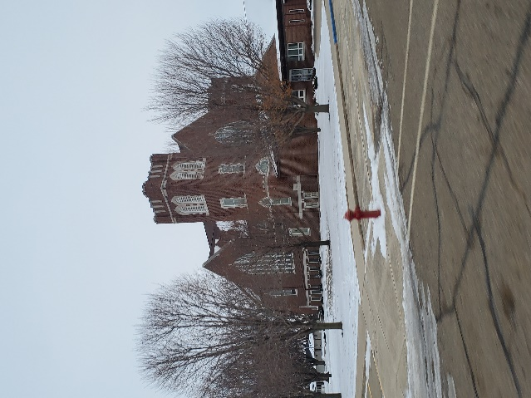

**References**

*Hospers, Iowa Population 2021*. Hospers, Iowa Population 2021 (Demographics, Maps, Graphs). (2021). https://worldpopulationreview.com/us-cities/hospers-ia-population.

The University of Iowa Libraries (2009). *THE BIOGRAPHICAL DICTIONARY OF IOWA*. Details Page - The Biographical Dictionary of Iowa - The University of Iowa Libraries. http://uipress.lib.uiowa.edu/bdi/DetailsPage.aspx?id=181.

City of Hospers. (2013). *Small Town Living with Big Ideas!* Hospers Iowa. http://hospersiowa.com/.